Remarkable Images

The Reverend Thomas Image and his family

When you enter St. Petronilla’s churchyard in Whepstead by the path in the north-east corner you cannot fail to notice the large family vault immediately in front of you. There are two large tombs and to the side are three smaller ones, all linked together. Inside the church is a tablet, on the north wall near the altar, which commemorates Frances and the Reverend Thomas Image and states that “their remains are interred in the vault near to the entrance”. Clearly all these graves are for various members of the Image family but who? I decided to find out more about Thomas Image and his family. Using papers in the church, various family history sources, newspaper articles and other information I discovered that Thomas was a remarkable man and his children and their offspring were also very interesting people. Several of them served as rectors in various parishes or married local clergy and one, Thomas’s son William, became well known in the medical world. The family bible for Thomas Image is in the church and this gives various dates and other information about his family. It also contains information on his father, John, so the bible may have initially belonged to him. Thomas Image was born during the reign of George III and while he lived in Whepstead the French Revolution and the Napoleonic Wars took place. He died in the early years of Queen Victoria’s reign.

Thomas was born on the 27th June and baptised on August 7th 1772, and was the son of John and Mary Image. His father John (1730 - 1786) was the son of a wigmaker. John went as an undergraduate to St. John’s College, Cambridge receiving financial help from the college. Here he obtained a Bachelor’s Degree in 1750 and a Masters in 1754. He was ordained a Deacon on the 22nd December 1751 by the Bishop of Norwich in St Ann’s Church, Westminster and a priest two year’s later. In December 1766 he became the vicar of St. John’s Peterborough and in 1769 vicar of the nearby village of Elton. At this time he was also a precentor and
minor canon of Peterborough Cathedral. It was thought that John died from a cold, caught whilst attending the execution of the last man hanged for stealing sheep. Letters from Edmund Image, the great grandson of Thomas to Canon Bird in 1932, stated that the Image family had come over from France in 1685 as tradesman.

Thomas Image was the longest serving rector of St. Petronilla’s and his portrait can be seen in the vestry. He was vicar for 58 years from 1798 until he died in 1856. On the list of rectors in the church his patron is given as Robert Freeman. He was educated at Corpus Christi College in Cambridge where he was a student of mathematics and graduated with a B.A. and an M.A. Apart from being the rector of Whepstead, he also took the curacy of Brockley in 1801 and Stanningfield in 1809. On the 15th January 1799 at Castor, Northamptonshire he married Frances Freeman. Was she the daughter of his patron? In the family bible he recorded his weight at various times up until 1814, when he was 13 stone 9 lbs. His great grandson, Edmund, wrote that in later life Thomas suffered from gout but continued to drink port wine.

In 1811 Thomas applied for and was given together with his sister Judith, a Coat of Arms. The College of Arms complemented him on the design and sent him a “small painting for the coach painter” to use on the side of his coach. He was also given copies to hang in his library. Unfortunately, I have been unable to find any pictures or copies of his Coat of Arms. This all cost him £74 and 4s. which today would be about £4,800.

During his time as vicar of St. Petronilla’s, Thomas was involved with several changes to the church. In 1809 he had a gallery installed at the tower end of the church to provide more seating for the congregation and house a small organ. Some years later the gallery was extended further but eventually removed. The accounts of the church wardens in 1810 show that the C14th font was re-ornamented with a gift from Thomas. By 1870 this font had disappeared and the present one was installed by his successor, Reverend Steele. At Thomas’s expense, in 1812, the East window of the church was embellished with stained glass. In 1814 he sold the lead from the roof to help pay for a new slate one. In 1827 Thomas had confirmed at St Mary’s, Bury St Edmunds, a remarkable 46 males and 32 females from Whepstead which was about 10% of the population of the village!

As well as church matters Thomas also helped in the village and administered the parish charities for the poor. After the end of the Napoleonic Wars in 1815 and with two poor harvests, life in rural parishes such as Whepstead became very difficult and more people relied on poor relief. In 1808 he made a loan of £158 to repair and extend the village workhouse. The workhouse occupied a row

of four cottages on land at the bottom of Church Hill. In 1836 the Thingoe Union of Parishes took over the running of the workhouse along with those in other local villages. Then in 1839 it was conveyed to Sir Francis Hammond of Plumpton Hall and the debt to Thomas was re-payed. The cottages were eventually pulled down in the 1960’s and the area is now a small wood. In 1833 he arranged for his son, William, to vaccinate 81 villagers, mainly children, against smallpox.
(Vaccination of infants against smallpox did not become compulsory until 1853).

One of the duties Thomas had as vicar of the parish was to collect the tithes due to the church. During his time as vicar the tithe became an issue. In December 1830 groups of labourers from Stanningfield and Whepstead met with Thomas to ask him to reduce the tithe so that their employers could pay them higher wages. He agreed to do this provided that they received the money deducted from them as extra pay. They also complained about having lost a day’s work to raise the matter so he then gave them money to buy refreshments. In 1832 he reduced the tithe by 10 percent. This shows that there was also a compassionate side to Thomas’s character. The system of collecting tithes was ended in 1836 by an Act of
Parliament but not commuted in Whepstead until 1843.

In May 1848 there was a serious fire at the Rectory in Whepstead. Although the Rectory itself was not damaged, the large tithe barn, stables, cow shed and cart lodges were all destroyed. In the barn were two cart-horses and a sow with piglets which were all killed by the fire. The direction of the wind had stopped the fire damaging the Rectory, but then the fire spread to two neighbouring thatched cottages. The fire had been started by one of Thomas’s servants who took off his coat containing a lucifer match which had dropped out of his pocket. The Suffolk and Norfolk fire engines prevented any further damage.

The favourite pastime of Thomas Image was collecting fossils and mineral samples and over 50 years he built up a collection which was considered to be one of the best in the country. One important find was that of the fossil of a sea turtle. For many years he employed collectors to search in local quarries near Cambridge, Newmarket and Bury St Edmunds. He studied the local chalk soil. The collectors also searched near the Norfolk and Suffolk coasts. Over time, Thomas built up a collection which illustrated the geology of East Anglia, from Cambridge to the coast. He was elected a Fellow of the Geological Society in 1840. When he died part of
his collection of fossils was sold and bought by the University of Cambridge where
they are now in the Woodwardian Collection at the Sedgwick Museum. They paid £250 (approximately £19,000 at today’s value). Having purchased the collection, Sedgwick then found he had to raise money to enable the museum to house it. To properly display Thomas Image’s collection involved an extensive rearrangement of the museum. Other specimens were offered for sale to the public. As well as being an accomplished musician Thomas was also an amateur artist. In the sale of his personal effects after he died were paintings by some well known artists such as Breughel. He also built up a large library of books on Geology, Botany and Natural History.

One of the most fascinating pages in the Image family bible is a handwritten text titled “The Deluge”. Whether it is original or has been copied from elsewhere is not known but it is especially interesting in the context of Thomas being a fossil collector. The article attempts to date the age of the earth from the scriptures giving dates up to 7685 years ago. The late C18th and early C19th was a period when significant fossils were being found and geologists were beginning to question the religious theory of creation. Fossil hunters began to realise that the earth was much older than most people thought. Charles Darwin who had returned from South America in 1836 spent several years worrying about his book “Origin of the Species” before publishing it in 1859 as he knew it was likely to upset the religious view of God creating the world. Sadly, Thomas died in 1856 so he would not have been able to read Darwin’s book on the theory of Evolution but it is intriguing to wonder if he knew of Charles Darwin’s work.

The Children of Thomas and Frances Image

Thomas and Frances had at least four children who survived to adulthood. None of their children are buried in Whepstead churchyard. Their first child was John, born on Thursday April 8th 1802. He married Mary Maxwell Hinds on the 25th March 1841 at St. Giles, Camberwell. She was born about 1808 in Barbados, West Indies. In the 1851 Census they were recorded as living in Ticehurst, Sussex where John was the curate. They had three children, Margaret born about 1844, John born about 1845 and Selwyn born February 17th 1849. By the time of the 1871 Census John’s wife was recorded as Sarah so presumably Mary had died and he
had remarried. Selwyn, like his father and grandfather became a clergyman, being ordained in 1872 and becoming a priest the next year. He gave up the priesthood in
1883 and co-founded the Century Guild of Artists in London. He gave lectures on modern art and Oscar Wilde, whom he had first become acquainted with at Oxford University, attended at least one of his lectures. Selwyn was also a poet and designer of stained glass.

Mary, the second child of Thomas and Frances, was born on the 19th January 1805. She married John White in Whepstead church on the 12th September 1826. The 1851 Census recorded John and Mary living in the Rectory at Chevington, Suffolk where John was the rector. He was then 65 years old, much older than Mary who was 46. Records show them as having had six children, 3 boys and 3 girls. Their eldest son John born in 1830 achieved a Bachelor of Arts Degree and subsequently took over the parish from his father.

The third child of Thomas and Frances was William Edmund Image. He was born on the 18th May 1807. He studied medicine and went to France to take his degree. Whilst he was there he lived with the well known French surgeon, M. Dupuytren. In Paris he met and married his first wife Desiree Catherine D’Enville in 1830 at the British Embassy. Both the 1841 and 1851 Censuses describe him living in Honey Hill, Bury St Edmunds as a surgeon. He became well known for his expertise in forensic medicine and poisoning cases. His wife Desiree died in 1872 and was buried in Whepstead churchyard. Following her death William married Fanny Eliza Mure who was the widow of George Mure. George had been in the Grenadier Guards and seen active service at Waterloo. After he left the army he became Master of the Suffolk Foxhounds.

William began collecting stamps and by 1882 had built up a large collection which he sold for £3,000 (about £250,000 at today’s prices) to Thomas Tapling. He donated his collection of philatelic literature to The Royal Philatelic Society, and these became one of their libraries important assets.

When William retired from his medical work he became a Justice of the Peace and in 1887 was the High Sheriff of Suffolk. In his later years he lived in Herringswell, where he died in 1903 aged 96 years and was buried in the local churchyard. Inside the church is a tribute in stained glass designed by his nephew Selwyn.

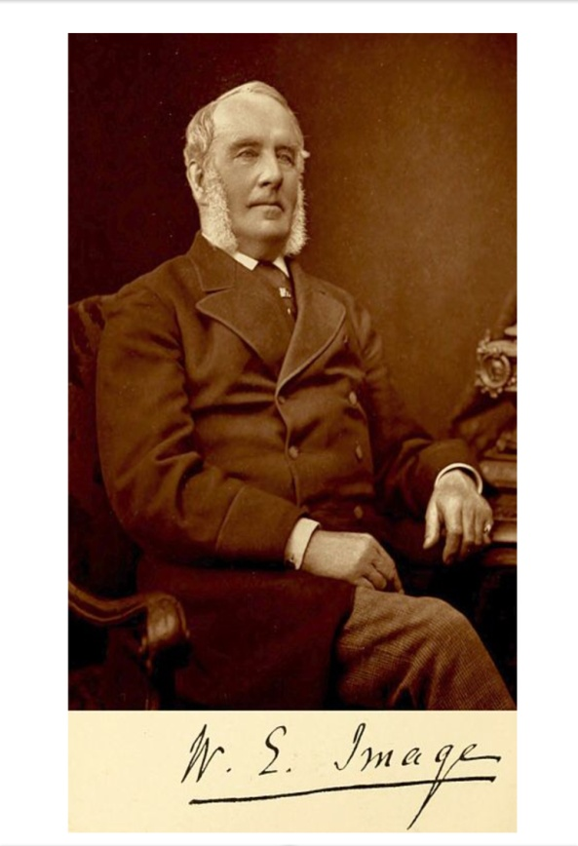
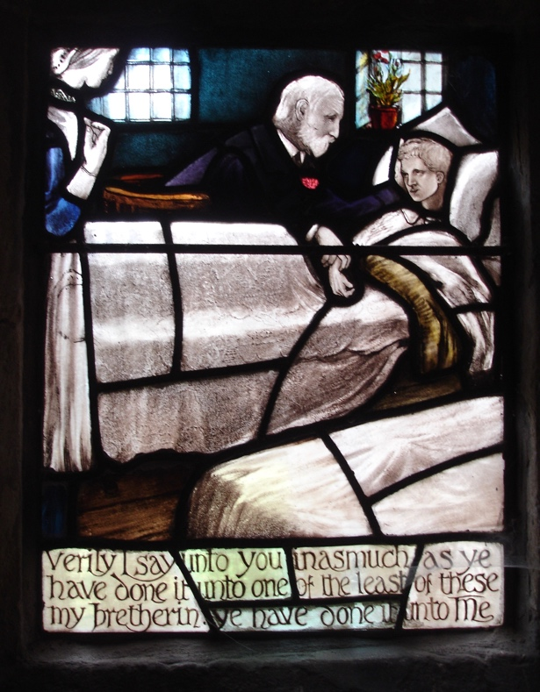

William Image Church window

Of the children of William and his first wife Desiree, William Thomas born in 1831 entered the priesthood and was instituted to the vicarage of Wickham Market in 1866 having formerly been the vicar of Windsor. Another son, Francis born in
1843, followed on from his father as surgeon at the Suffolk General Hospital in 1873. Six of William and Desiree’s children died in infancy.

The youngest daughter of Thomas and Frances, Adelaide was born on the 15th July 1810. She married John Lillistone on the 7th November 1829, who was the Rector of Barsham, Suffolk. In 1831 her son died aged 9 weeks and then in June 1839 her husband, John, died aged 42. Both of them were buried in the Holy Trinity churchyard in Barsham. The 1841 Census recorded Adelaide as living in Whepstead with her father and mother, Thomas and Frances. Adelaide married William Cawston in July 1843 and they subsequently lived in Worlingworth, Suffolk. In the 1851 Census William Cawston’s occupation was a surveyor and land valuer.

The Image family tomb.

In the north east corner of the churchyard is the large Image family tomb. From the plaque inside the church and the inscriptions on the tombstones we know about the two large graves. The first one on the left is of Desiree Catherine Image, born in France, the first wife of William, son of Thomas and Frances, who was buried the 23rd July 1872. The next largest one is for Thomas and Frances who died in 1856 and 1842 respectively.
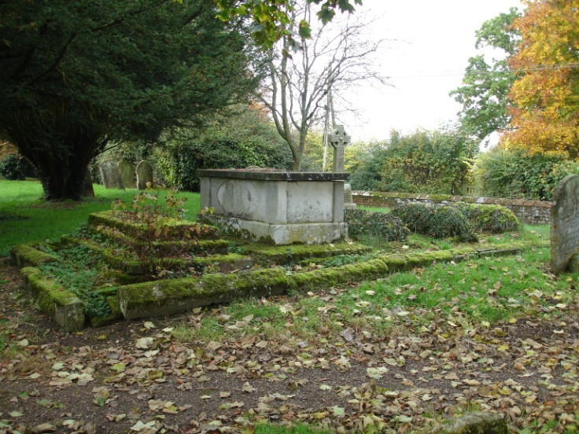
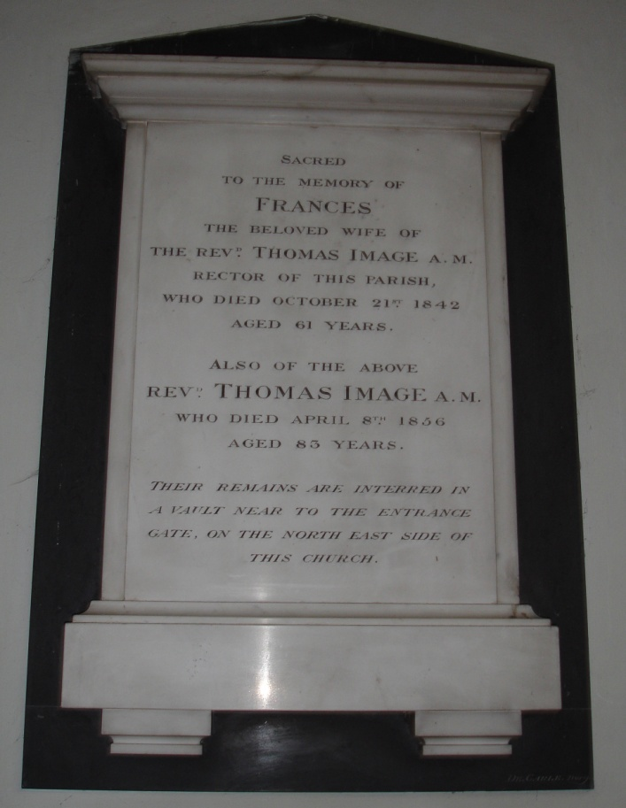

According to the burial records for the church six of Thomas’s grandchildren are also buried in the churchyard, but there are only three small tombs. Unfortunately, due to the erosion of the stone and growth of vegetation it is not possible to make out the inscriptions. The small tombs are thought to be of the children of William and Desiree Image who were living in Bury St Edmunds at that time. In the records they were given as dying in infancy, which was anytime up until their first birthday. As there are only three small graves, are there two children buried in each? The burial dates shown in the table suggest this might have been

possible. We do not know why they died so young, especially as their father was in
the medical profession. During the period 1813 to 1872, 37% of all the burials in
Whepstead churchyard were for children less than a year old. The
most common causes of infant mortality in the 1800’s were Tuberculosis, Diphtheria, Scarlet Fever and Whooping Cough. The Image family bible records that John Image, son of Thomas, had measles in September 10th 1806.

Image children | Birth date | Burial date in Whepstead
Jane Trenchard | 17 July 1838 | 16 August 1838
Trenchard Pickard | 5 July 1839 | 14 November 1839
Trenchard Edmund | 2 October 1840 | 19 March 1841
Catherine Desiree | 15 January 1842 | 13 May 1842
Juliana Frances | 2 September 1844 | 1 April 1845
Trenchard Weston | 11 January 1847 | 26 June 1847

Stephen Cousins 2015

